**PROJECT DEVELOPMENT PHASE**

**DELIVERY OF SPRINT 3**

|  |  |
| --- | --- |
| **Date** | **10 November 2022** |
| **Team ID** | **PNT2022TMID13205** |
| **Project Name** | **Ai Based Discourse For Banking Industry** |
| **Maximum Marks** | **8 Marks** |

**Actions**

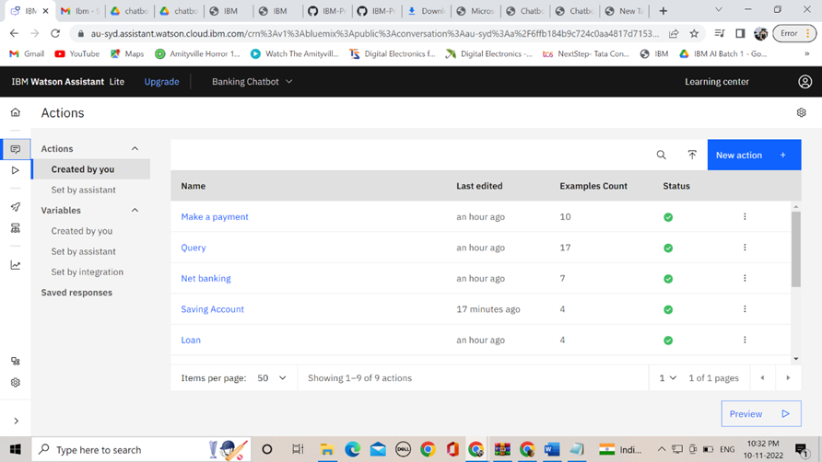

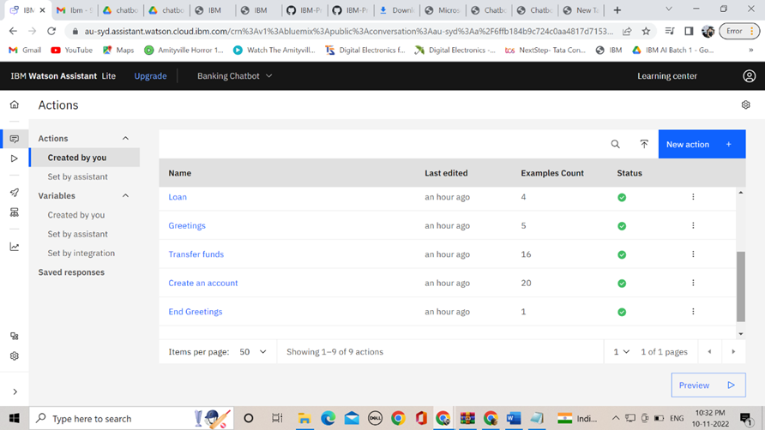

**Analysis**

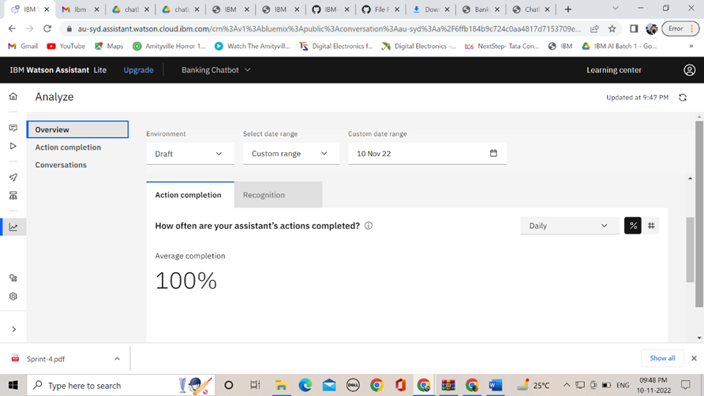

**Preview**

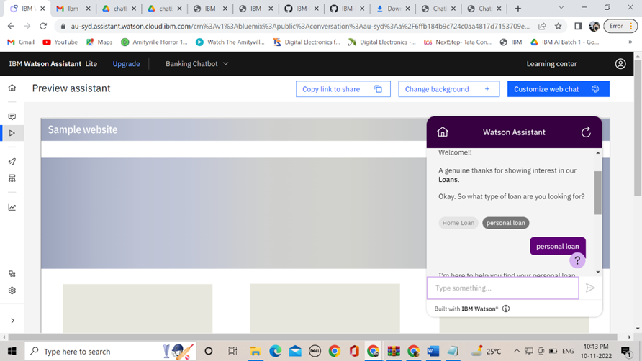

**Web Page with Flask integration**

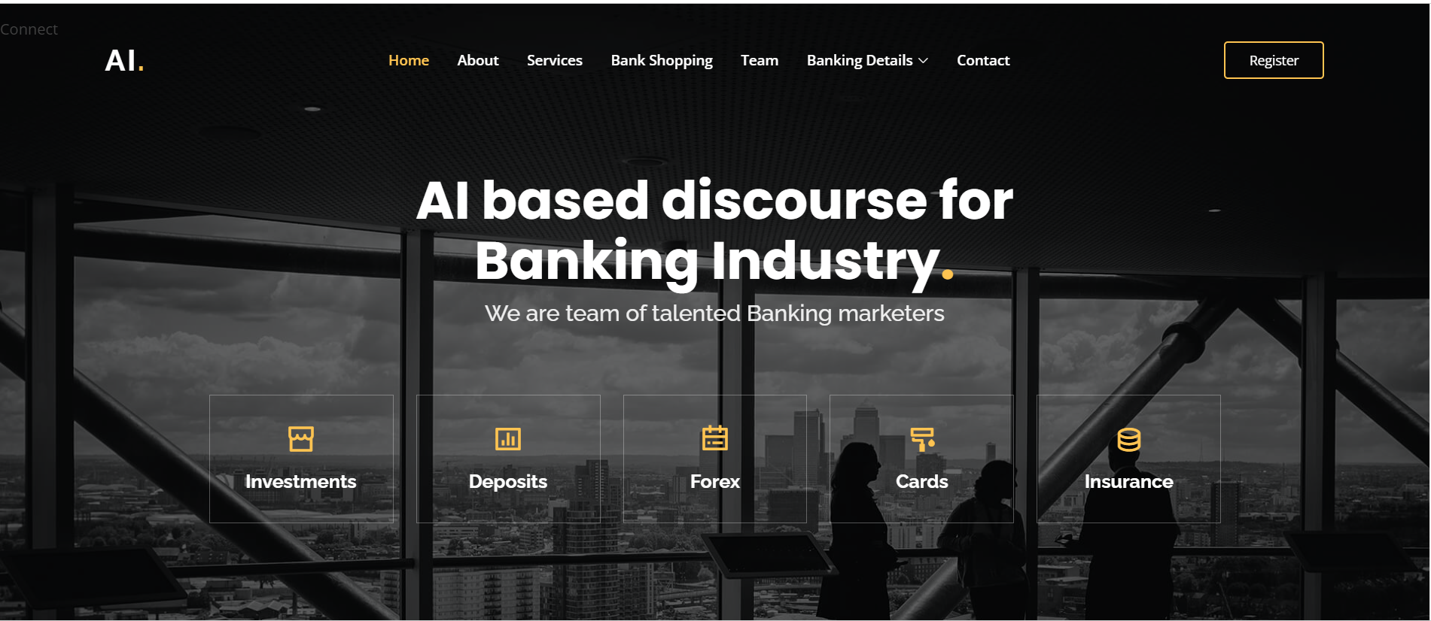

**Note: In this Sprint 3, there is no code needed to create assistant and skills, it purely based on Actions and steps**